Zev-7
Nixie Clock
Assembly Manual

April 2026
This manual describes the assembly, testing, and bring-up of the Zev-7 Nixie Clock from bare PCB and components.
Revision/Update Information: | Document Revision 1.0
Hardware Revision: | A
Companion Firmware Version: | 1.0.2
Designed by Mitchell Feig
Copyright © 2026 Mitchell Feig

Table of Contents

1. Introduction 1-1
2. Safety Warnings 2-1
3. Required Tools and Equipment 3-1
4. Assembly Sequence 4-1
5. Initial Power-On and Testing 5-1
6. Troubleshooting6-1
Appendix A — Bill of Materials A-1
Appendix B — Schematics B-1

1. Introduction

This manual covers the assembly of the Zev-7 Nixie Clock from bare PCB and components. The Zev-7 uses seven Nixie tubes driven by three HV5530 high-voltage shift registers, an ESP32 microcontroller for WiFi and NTP timekeeping, a high-voltage boost converter, and addressable RGB LED backlighting.
The circuit is documented across four schematic sheets reproduced in Appendix B:
- Power Supply (ps.dxf) — 12V input, 5V regulator, 170V HV supply
- Processor (cpu.dxf) — ESP32, level shifter, Schmitt trigger, sensors, buttons
- Display (nixie.dxf) — HV5530 shift chain, Nixie tubes, neon indicator lamps
- RGB LEDs (led.dxf) — APA106 tube backlights, APA102 under-lights
Components should be soldered in the order presented in Section 4, progressing from low-profile parts to tall components, and from power to signal to display.

2. Safety Warnings

WARNING: This circuit generates approximately 170V DC for the Nixie tube anodes. This voltage is lethal. Never touch any part of the high-voltage circuit while the clock is powered on. Always disconnect power and wait at least 30 seconds for capacitors to discharge before working on the board.
WARNING: Nixie tubes are glass and fragile. Handle tubes by the base only. Do not apply excessive force when inserting tubes into sockets.
CAUTION: Observe correct polarity on all electrolytic capacitors (C1, C2, C3), diode D2, and ICs. Reversed polarity can cause immediate component damage.
CAUTION: The LM2576T-5.0 and Tayloredge 1363 module may become hot during operation. Allow adequate ventilation and do not touch metal tabs during operation.
NOTICE: If for any reason the above conditions and the copyright notice at the end of this manual cannot be met, return the kit or assembled clock in original condition within 30 of purchase for a full refund, less shipping.

3. Required Tools and Equipment

Soldering
- Temperature-controlled soldering iron (recommended 350°C / 660°F)
- Fine solder (0.5–0.8 mm rosin-core, 60/40 or lead-free)
- Solder flux (liquid or paste)
- Solder wick or desoldering pump
- Tweezers (fine-tip, for SMD components)
- Magnifying visor or bench magnifier

Test Equipment
- Digital multimeter (must measure DC voltage up to 200V)
- 12V DC power supply (minimum 1A, center-positive)
- Oscilloscope (optional, useful for debugging data signals)

Hand Tools
- Wire strippers and flush cutters
- Anti-static wrist strap

4. Assembly Sequence

Assemble in the order below, progressing from lowest-profile components to tallest, and from power to signal to display. Test each section before proceeding to the next.

4.1 Step 1: Power Supply
Build and test the power supply first to ensure clean voltage rails before installing sensitive ICs.
Install Components
1. F1 (1 A fuse)
2. C1 (330 µF 16V) — Observe polarity.
3. LM2576T-5.0 — Tab is oriented toward the outside of the board.
4. D2 (1N5819) — Cathode band as marked on PCB.
5. L1 (100 µH)
6. C2 (330 µF 16V) — Observe polarity.
7. R1 (10k), R22 (39k)
8. J1 (DC barrel jack)
Test the 5V Rail
Connect a 12V supply to J1. Measure the output with a multimeter:
- VCC / VDD rail should read 5.0V ± 0.1V
- If voltage is incorrect, check D2 orientation and L1 connections
Disconnect power before proceeding.
Install HV Supply
9. HVPS1 (Tayloredge 1363) — Temporarily connect a wire between pin 10 and +5V to enable the power supply.
Test
Apply 12V power. Check the 170v, 12v, and 5v test points with a meter. The HV supply will read approximately 172v. Remove the temporary wire.

4.2 Step 2: Processor and Support ICs
SMD Components First
Solder all SMD parts before through-hole components.
1. C3 (100 µF), C4-C11 (100 nF ceramic) — Decoupling and bulk capacitors. Solder these first as they are the lowest-profile components.
2. R14 (39k), R15 (2.7k), R16 (2.7k), R17 (10k), R18 (10k)
3. U3 (74HCT14D, SOIC-14) — Verify pin 1 alignment.
4. U8 (CD4504BM, SOIC-16) — Verify pin 1 alignment.
Through-Hole Components
5. U1 (ESP32 PICO) — Do not solder the module to the board! Cut the single row header strip to fit, and solder in place.
6. Q23 (TEPT4400) — Lens faces outward toward ambient light. Shorter lead toward the flat side of the screening.

4.3 Step 3: Display Drivers (HV5530)
1. U4-U6 (HV5530, PLCC-44) — Carefully orient the three sockets. Orient the socket so the flat corner is on the back-left of the board.
WARNING: Do not get this wrong. It is extremely difficult to remove these sockets once soldered, and requires specialized equipment.

4.4 Step 4: Nixie Tubes and Neon Lamps
WARNING: The anode resistors connect to the 170V HV rail. Double-check all connections before applying power. A short on the HV rail can damage components instantly.
Anode Resistors
1. R2–R8 (15k, ×7) — Anode resistors.
Neon Lamp Resistors
2. R9–R13 (270k, ×5) — Neon lamp resistors.
Nixie Tube Sockets, Boards, and Tubes
3. Install tube sockets — Solder sockets for NX1–NX7. Do not insert tubes until the HV rail has been verified.
4. Different tube types are available. Each tube type requires a specific tube board. Carefully solder each tube to a tube board, noting the side on which to install the tube. First install the male connector to the tube board, then the tube on the other sie.
5. Install neon lamps — NE1–NE5.
Tube Position Reference
Tube | Position | Displays | Anode Resistor | Driven By
NX1 | Leftmost pair | Hours tens | R8 | U6
NX2 |  | Hours ones | R7 | U6
NX3 | Middle pair | Minutes tens | R6 | U6
NX4 |  | Minutes ones | R5 | U5
NX5 | Rightmost pair | Seconds tens | R4 | U5
NX6 |  | Seconds ones | R3 | U5
NX7 |  | Tenths of second | R2 | U4

Neon Lamp Reference
Lamp | Position | Signal | Resistor | Function
NE1 | Between NX1/NX2 | TLNeon | R9 | Top-left colon
NE2 | Between NX1/NX2 | BLNeon | R10 | Bottom-left colon
NE3 | Between NX3/NX4 | TMNeon | R11 | Top-middle colon
NE4 | Between NX3/NX4 | BMNeon | R12 | Bottom-middle colon
NE5 | Near NX7 | BRNeon | R13 | Right indicator

4.5 Step 5: RGB LEDs
Chain 1: Tube Backlights (APA106)
1. R19 (150Ω)
2. LED1–LED7 (APA106) — The longer pins go toward to dot on the silkscreen. Before soldering, temporarily install a tube board and push the LED up into the hole in the board as far as it will go.
Chain 2: Under-Lights (APA102)
3. R20 (150Ω), R21 (150Ω)
4. LED8–LED11 (APA102) — Note the orientation.
CAUTION: APA106 and APA102 LEDs have different pinouts. Carefully follow the silkscreen when installing.

4.6 Step 6: Sensors
BME280 Temperature/Pressure/Humidity Sensor
1. J3 (4-pin header) — BME280 I²C sensor connector.
The BME280 is auto-detected at I²C addresses 0x76 and 0x77. The sensor is optional — the clock operates normally without it.
PIR Motion Sensor
2. J2 (PIR connector)
Light Sensor
3. Q23 (TEPT4400) — Already installed in Step 2.

4.7 Step 7: Buttons and Connectors
1. SW1 (Pushbutton)
2. SW2 (Pushbutton)

5. Initial Power-On and Testing

WARNING: Do not insert Nixie tubes until the HV rail has been verified.

Pre-Power Checks
Before applying power for the first time:
- Visually inspect all solder joints under magnification
- Check for solder bridges, especially on SOIC and PLCC packages
- Verify all electrolytic capacitor polarities (C1, C2, C3)
- Verify diode orientations (D2, D3)
- Confirm no shorts between power rails: measure resistance between VCC and GND, HV and GND

Power-On Sequence
1. Connect 12V supply to J1. Current draw should be under 100 mA with no tubes installed.
2. Verify voltages:
- VCC / VDD: 5.0V ± 0.1V
- VEE (ESP32 3.3V rail): 3.3V ± 0.1V
- HV rail: 170V (no adjustment needed)
3. The ESP32 should create a WiFi access point named "Zev-7" on first boot.
4. Connect from a cell phone or PC to the access point a browser to 192.168.4.1. At a minimum select the network and enter the network password. Scroll to the bottom of the form and press Save. Press Back, and then Start, on the home page.
5. After WiFi connects, the display shows the startup sequence, and starts running.

Testing Subsystems
LEDs: After WiFi connection and time sync, the RGB backlights should activate with the default "Random Multi" effect. If LEDs do not light, check R19, R20, R21, U3, and data line continuity.
Buttons: Press SW1 — should trigger a button override. Hold SW2 for 5 seconds — should restart in AP mode.
Sensors: If BME280 is connected, enable it in Setup. Temperature, humidity, and pressure appear in the info display cycle. Triple-click SW2 to verify the light sensor (raw reading on NX1–NX2).

6. Troubleshooting

Symptom | Check | Solution
No power (nothing lights) | F1 fuse, J1 connection | Replace fuse. Check barrel jack center-positive.
5V rail incorrect | LM2576 connections, D2 orientation, L1 | Verify LM2576 pinout. Check D2 Schottky cathode direction. Confirm L1 value.
ESP32 not booting | VEE (3.3V), solder joints on module | Reflow ESP32 module pins. Check for shorts on IO0 (must be high for normal boot).
LEDs not lighting | R19, R20, R21, U3 (74HCT14D), VCC to LEDs | Verify 5V at LED VCC pins. Check R19 / R20 / R21 continuity. Verify U3 pin 14 = 5V.
LED chain partially works | Failed LED in chain | Data cascades: a dead LED breaks the chain. Replace the first non-working LED.
No display (tubes dark) | HVENABLE, HV rail, R2–R8 | Verify HVENABLE is high when display should be on. Check HV voltage. Verify anode resistors.
Wrong digits displayed | DATA / CLK / LE wiring, U8 level shifter | Verify U8 connections. Check shift chain order (U6→U5→U4). Confirm CLK / LE / DATA signals with scope.
Digits dim or flickering | HV voltage, BL (blanking) signal | Verify HV rail at 170V. Verify BL PWM signal from IO13 through U8.
Neons not working | R9–R13, HV5530 outputs for neons | Verify 270k resistors. Check that neon outputs toggle (use scope on HV5530 output pins).
No WiFi AP on first boot | ESP32 flash, antenna | Reflash firmware via USB. Ensure no metal near ESP32 antenna area.
BME280 not detected | J3 wiring, I²C pull-ups R15 / R16 | Verify SDA / SCL at J3. Check R15 / R16 to 3.3V. Try alternate I²C address module.
PIR not responding | J2 wiring, C7, IO37 | Verify signal at IO37. Check PIR module power (3.3V). Confirm C7 decoupling.
Light sensor not reading | Q23 orientation, R14 | TEPT4400 must face ambient light. Verify R14 (39k) and signal at IO38.

Appendix A — Bill of Materials

Component values reflect the latest schematic revisions in Appendix B. Reference designators match the silkscreen on the PCB.

Integrated Circuits
Ref | Part | Package | Qty | Description
U1 | ESP32 PICO KIT V3 | Module | 1 | ESP32-PICO-D4 WiFi microcontroller
U3 | 74HCT14D | SOIC-14 | 1 | Hex inverting Schmitt trigger
U4 | HV5530 | PLCC-44 | 1 | HV shift register (NX7 + BR neon)
U5 | HV5530 | PLCC-44 | 1 | HV shift register (NX4, NX5, NX6 + TM/BM neons)
U6 | HV5530 | PLCC-44 | 1 | HV shift register (NX1, NX2, NX3 + TL/BL neons)
U8 | CD4504BM | SOIC-16 | 1 | CMOS hex voltage level shifter
— | LM2576T-5.0 | TO-263-5 | 1 | 5V 3A switching regulator
HVPS1 | Tayloredge 1363 | Module | 1 | HV boost converter (~170V)

Resistors
Ref | Value | Qty | Description
R1 | 10k | 1 | HV voltage divider
R2–R8 | 15k | 7 | Nixie tube anode current limiters
R9–R13 | 270k | 5 | Neon lamp current limiters
R14 | 39k | 1 | Light sensor (TEPT4400) load resistor
R15, R16 | 2.7k | 2 | I²C pull-ups (SDA, SCL)
R17 | 10k | 1 | HVENABLE pull-down
R18 | 10k | 1 | Button pull-up (SW2)
R19 | 150Ω | 1 | APA106 data line series resistor
R20 | 150Ω | 1 | APA102 data line series resistor
R21 | 150Ω | 1 | APA102 clock line series resistor
R22 | 39k | 1 | 39k resistor

Capacitors
Ref | Value | Qty | Description
C1 | 330 µF 16V | 1 | Input filter (12V rail), electrolytic
C2 | 330 µF 16V | 1 | Output filter (5V rail), electrolytic
C3 | 100 µF | 1 | ESP32 supply bulk capacitor
C4–C11 | 100 nF | 8 | Decoupling capacitors (ceramic)

Diodes
Ref | Part | Qty | Description
D2 | 1N5819 | 1 | Schottky catch diode (LM2576)
D3 | Protection diode | 1 | VCC protection (near ESP32)

Inductors and Fuses
Ref | Value | Qty | Description
L1 | 100 µH | 1 | LM2576 buck converter output inductor
F1 | 1 A fuse | 1 | Input power fuse

Nixie Tubes and Neon Lamps
Ref | Part | Qty | Description
NX1–NX7 | Nixie tube | 7 | Numeric display tubes (digits 0–9)
NE1–NE5 | Neon indicator lamp | 5 | Colon and status indicators
 | 12 Pin Male Socket | 7 | Mounts to PC Board
 | 12 Pin Female Socket | 7 | Mounts to the bottom of the tube boards

LEDs
Ref | Part | Qty | Description
LED1–LED7 | APA106 RGB LED | 7 | Tube backlight (single-wire, IO32)
LED8–LED11 | APA102 RGB LED | 4 | Under-light (SPI, IO32 / IO27)

Connectors, Switches, and Sensors
Ref | Part | Qty | Description
J1 | DC barrel jack | 1 | 12V power input
J2 | PIR connector | 1 | PIR motion sensor header
J3 | 4-pin header | 1 | BME280 I²C sensor connector
SW1 | Pushbutton | 1 | Button 1 (override, IP, OTA)
SW2 | Pushbutton | 1 | Button 2 (calibration, AP mode)
Q23 | TEPT4400 | 1 | Ambient light phototransistor

Appendix B — Schematics

Each of the four schematic sheets is reproduced in landscape orientation on its own page on the pages that follow. Sheets are presented in the assembly order: Power Supply, Processor, Display, RGB LEDs.
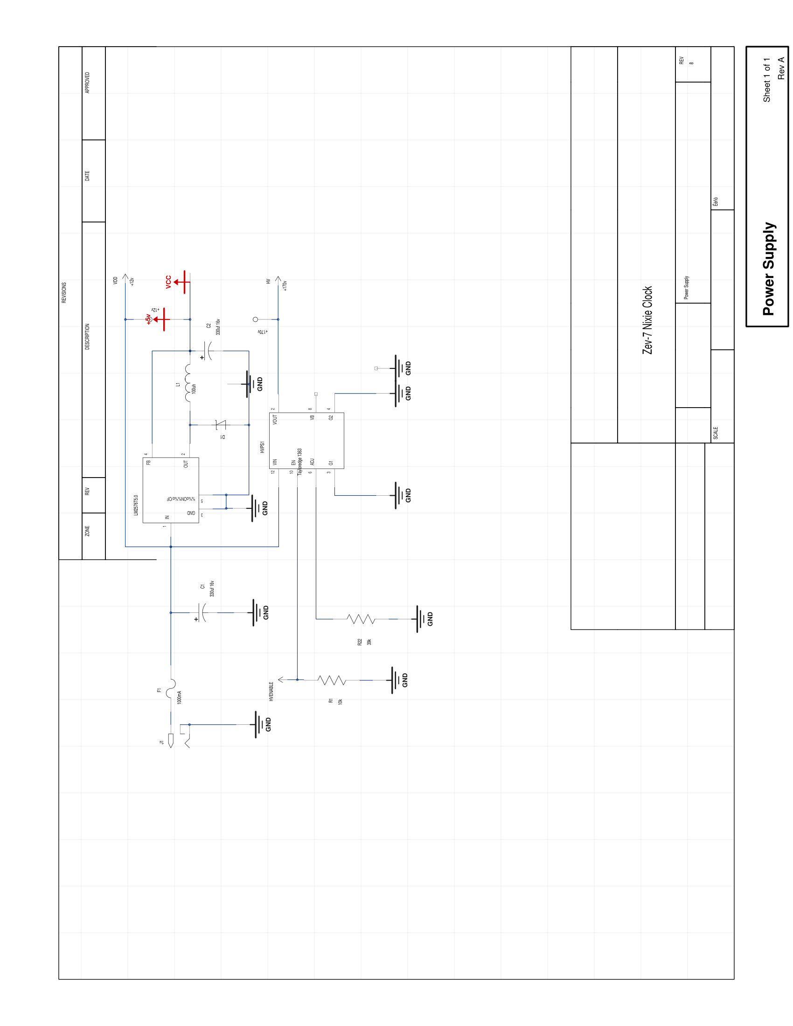
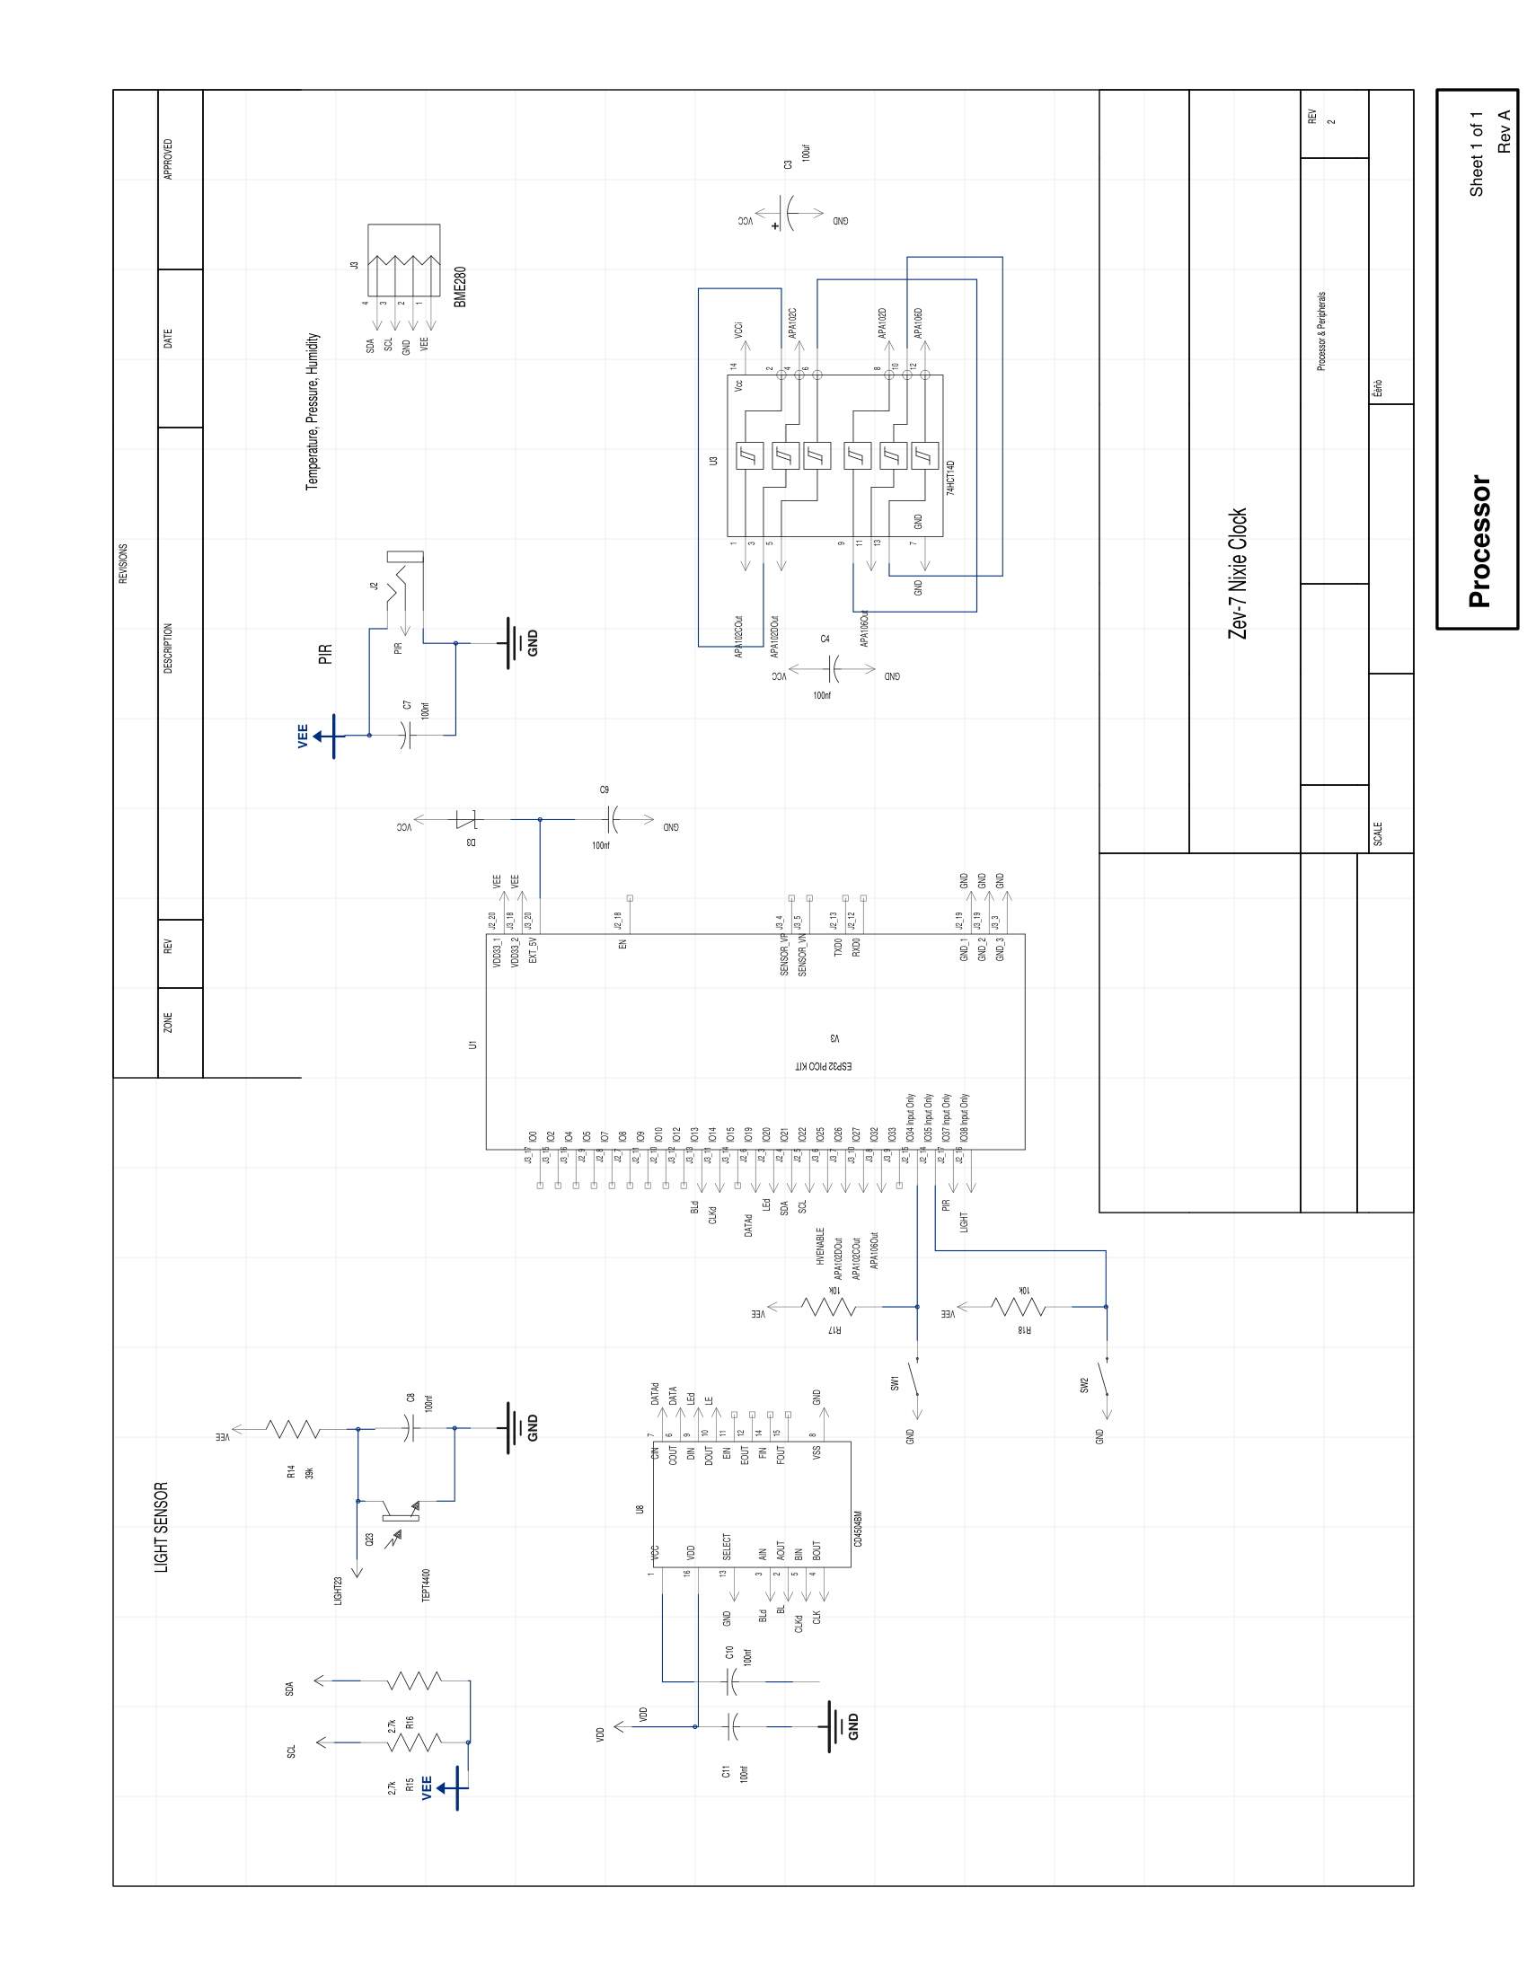
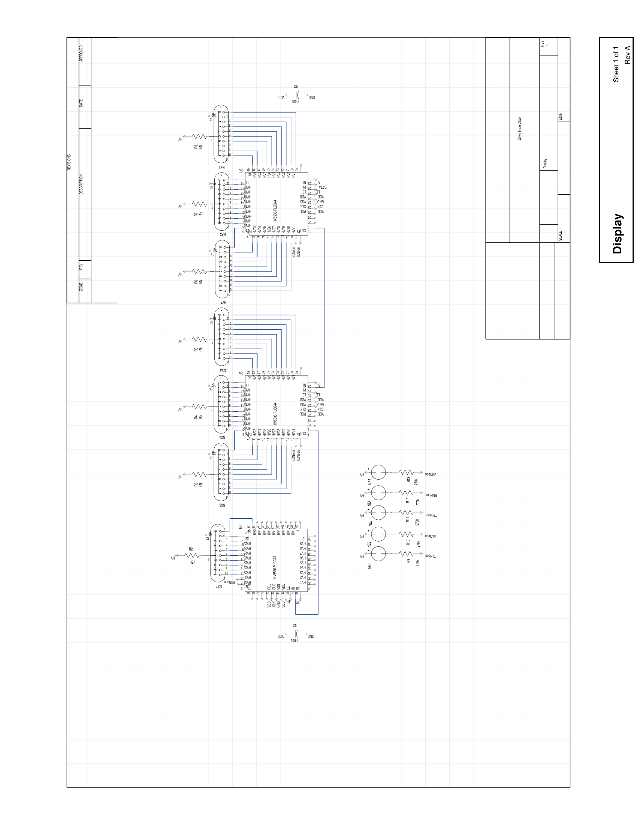
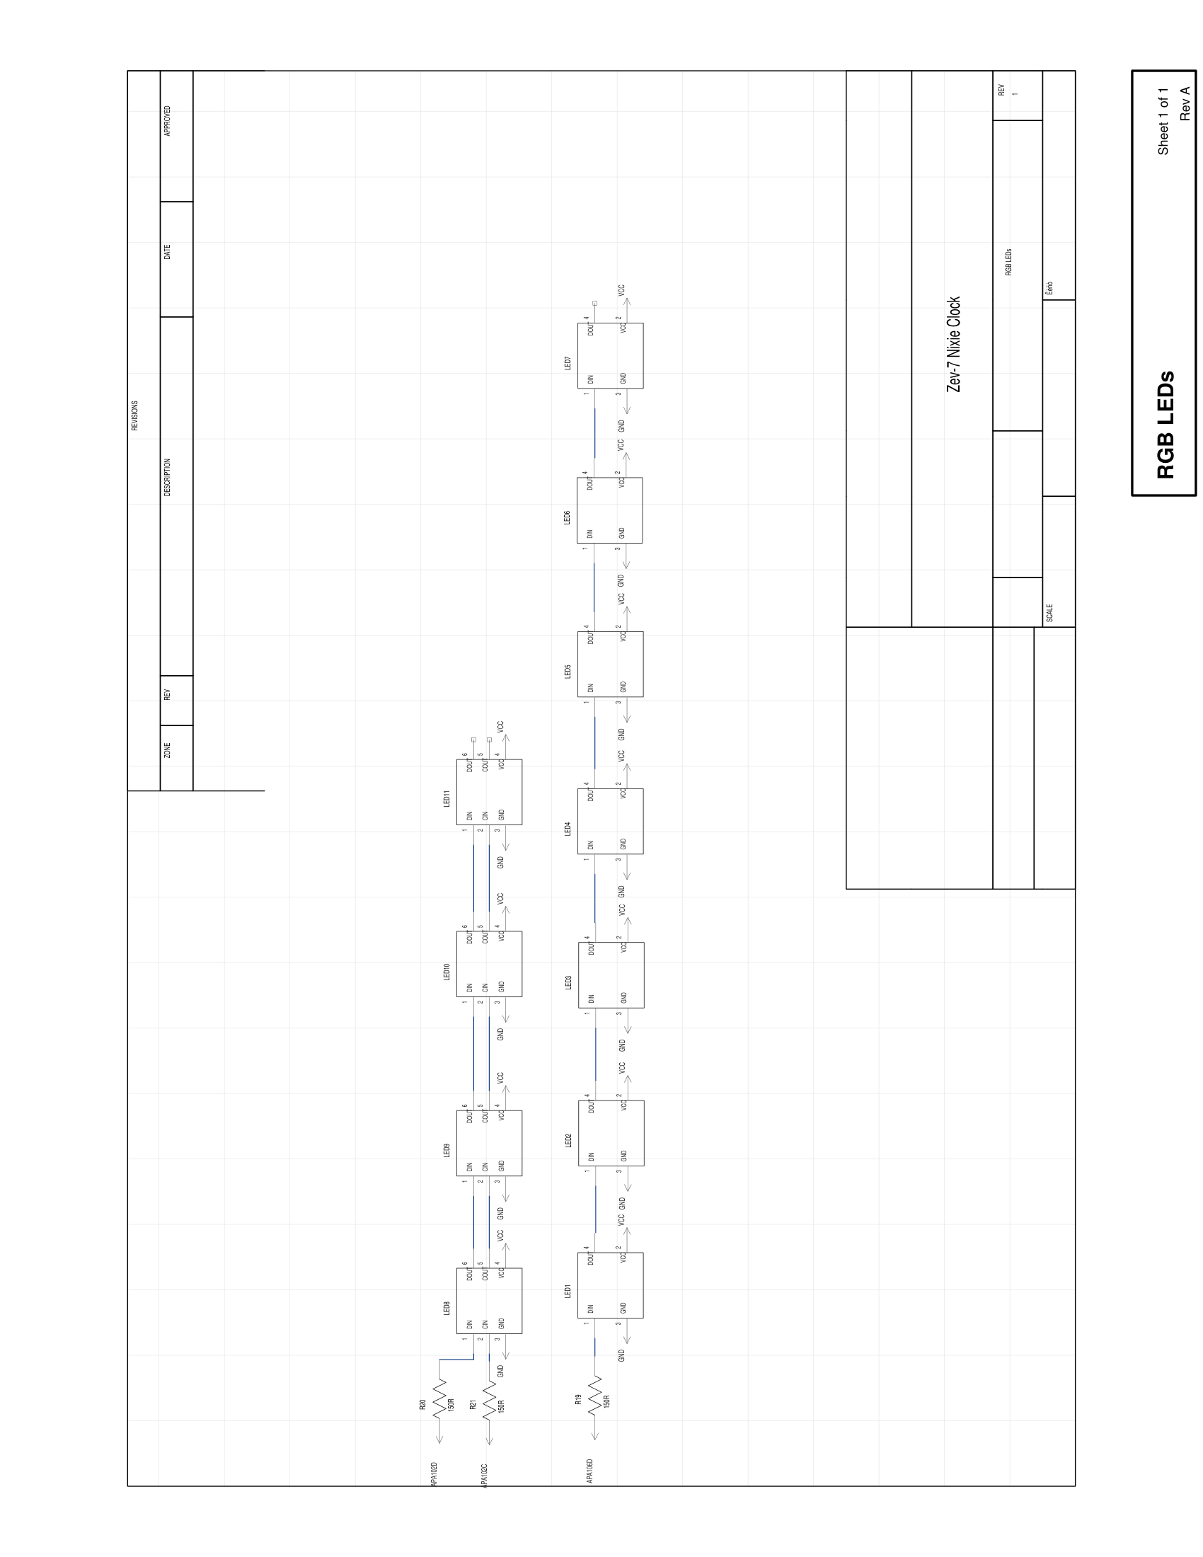

Copyright and Disclaimer

Zev-7 Nixie Clock hardware design and documentation © 2026 Mitchell Feig. All rights reserved.
THIS PRODUCT IS PROVIDED "AS IS", WITHOUT WARRANTY OF ANY KIND, EXPRESS OR IMPLIED, INCLUDING BUT NOT LIMITED TO THE WARRANTIES OF MERCHANTABILITY, FITNESS FOR A PARTICULAR PURPOSE, AND NONINFRINGEMENT. IN NO EVENT SHALL THE AUTHOR OR COPYRIGHT HOLDER BE LIABLE FOR ANY CLAIM, DAMAGES, OR OTHER LIABILITY ARISING FROM, OUT OF, OR IN CONNECTION WITH THE PRODUCT OR ITS DOCUMENTATION.
The Nixie tubes used in this clock contain a small amount of mercury and neon gas under low pressure. The high-voltage circuitry inside generates approximately 170 volts and should not be touched while the clock is powered on.
Zev-7 Nixie Clock — Designed by Mitchell Feig

